California State Polytechnic University, Pomona College of Engineering

Electrical and Computer Engineering Department

Senior Project 2019-2020

**SODAR DEVICE**

**ABET Compliance Report**

By: Yohannes Teclemariam (EE), Josiah Ebreo (EE), Lorenzo Chan (EE),

and Abraham Nkum (CE)

Advisor: Dr. Hyoung Soo Kim

# Abstract

For our project we are repurposing a Sound Detection and Ranging (SODAR) device to find objects in the atmosphere and building an interface that will display where the objects are and distance from the SODAR device. Our simulations for calculation purposes and signal processing for testing purposes will be performed on LabVIEW programs. The SODAR device in its simples form will consist of an Arduino with an Ultrasonic sensor on a rotating top that will be responsible for finding objects in the atmosphere. The Adriano will communicate with the lab top via Wi-Fi, and display the objects detected on a user interface. Once the initial project requirements are met, we aim to improve range capabilities, accuracy and battery consumption of the device.

# Acknowledgements

We want to thank our advisor, Dr. Hyoung Soo Kim, who would continue to advise and support us throughout the project.

**Table of Contents**

Abstract ………………………………………………………………………………. 2

Acknowledgements ………………………………………………………………..... 2

Table of Contents ……………………………………………………………………. 3

List of Figures & List of Tables ……………………………………………………. 4

Introduction …………………………………………………………………………. 5

Requirements and Specifications ………………………………………………... 6

Project Planning and Task Definition ……………………………………………. 6

Design Decision and Contributions …………………………………………….... 7

Primary Constraints …………………………………………………………… 9

Engineering Standards………………………………………………………….. 9

Global Impact……………………………………………………………………. 9

Economic Impact………………………………………………………………….. 10

Ethical and Professional Responsibility Judgement…………………………….. 10

**List of Figures and Tables**

|  |  |
| --- | --- |
| Figure 1. Equation for Doppler Effect ……………………………………………………………………….. | 5 |
| Figure 2. Arduino …………………………………………………………………………………………………… | 7 |
| Figure 3. Rotating top Assembly ……………………………………………………………………………… | 8 |
| Figure 4. User Interface ………………………………………………............................................. | 8 |

**Introduction**

SODARs are useful tools for measuring aspects of the atmospheric boundary layer (ABL) such as wind speed and turbulence. In the early stages of their development they were employed to measure the height of the boundary layer by recording the strength of the return echo. By employing several beams in a complimentary arrangement it is possible to solve a set of simultaneous equations to give the wind speed and direction at many points within the measurement height range. Using the Doppler Effect with a multi-beam configuration to determine wind speed, they are the exact in-air equivalent to a subclass of sonar systems known as [acoustic Doppler current profilers](https://en.wikipedia.org/wiki/ADCP).

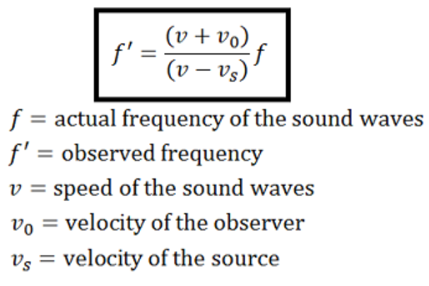

Figure 1. Equation for Doppler Effect

For our project we are repurposing a Sound Detection and Ranging (SODAR) device to find objects in the atmosphere and building an interface that will display where the objects are and distance from the SODAR device.

SODAR systems use sound waves as a method of detection. [Sound waves](http://socratic.org/physics/sound/sound-waves) are longitudinal waves that propagate through space from particles colliding with each other. The system would emit sound waves which would reflect off a certain object in its range and be detected the sensor. The time it takes to for the sound to send and reflect off the object can be used to determine the distance of object. The direction at which the Ultrasonic senor is facing in combination with the distance can be used to find the position relative to the SODAR device and displayed on the user interface.

**Requirements and Specifications**

* To create a freely rotatable and portable SODAR system that can continuously detect objects.
* To create a user interface (UI) that displays objects similarly to radar.
* Minimum radius of 5 feet for detection of objects.

**Project Planning and Task Definition**

Semester 1 (Fall 2019)

* Week 1-6 Project Initiation

Creating objectives and scope and doing background research. This includes research on design specifications, feasibility and choosing an approach.

* Week 7-10 Project Planning

Setting timelines, creating material requisite list, budgeting and retrieving necessary materials.

* Week 11-13 Project Execution

Creation and testing of the communication system using Adriano to Wi-Fi module connection.

* Week 14-15 Project Execution

Start with the creation of SODAR device. This includes hardware and software components.

Semester 2 (Spring 2020)

* Week 1-4 Project Execution

Creation of SODAR device and testing. This includes hardware and software components.

* Week 5-10 Project Execution

Creation of user interface (UI) and integrated testing of entire project.

* Week 11-12 Closing

Final report and presentation.

Yohannes Teclemariam – Project manager, Software development, research, costs management, battery management, integration testing.

Lorenzo Chen – Hardware development, PSPICE modeling, research, meeting minutes, charts, and report.

Abraham Nkum – User Interface (UI), LabVIEW, research, research paper and presentation.

Josiah Ebreo – Communication Systems, Software development, integration and tests.

**Design Decision and Contributions**

Hardware

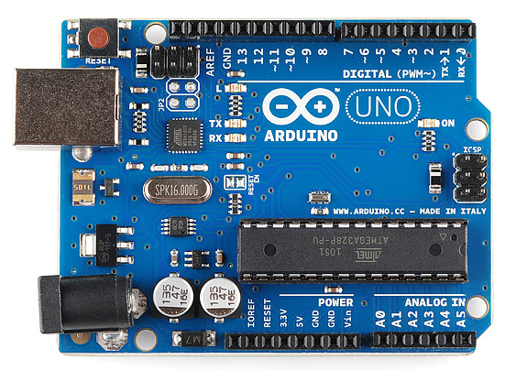

Figure 2. Arduino

* 9 volt battery
* Arduino
* Ultrasonic Sensor
* Laptop
* Platform with rotating top where we can place Arduino and Sensor
* Motor to rotate top

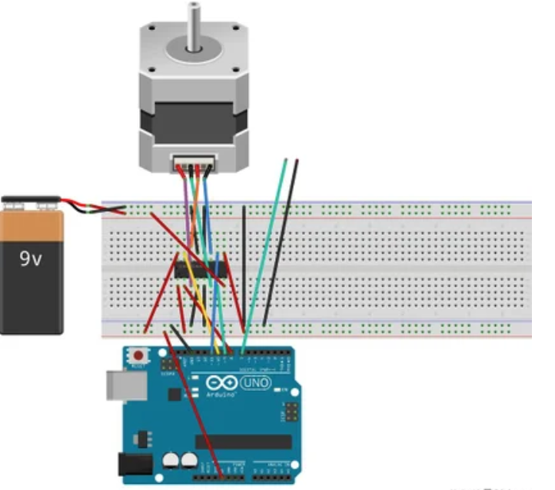

Figure 3. Rotating top Assembly

User Interface

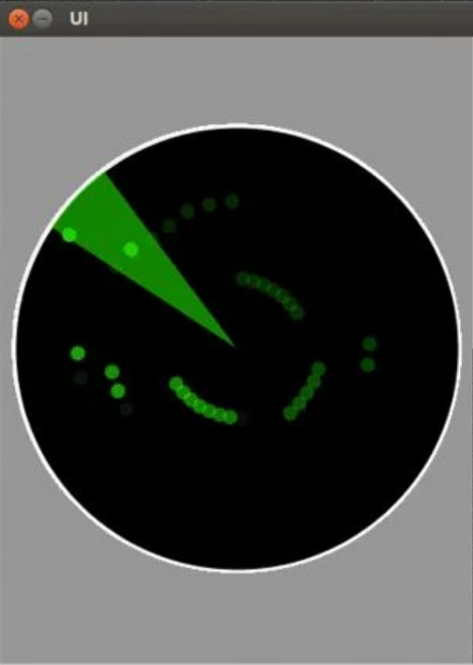

Figure. 4 User Interface

* User interface will display objects detected by the SODAR device via LabVIEW.

**Primary Constraints**

The primary constraints of our project consist of three major parts. These include the functionality of or SODAR device, cost and quality. Our SODAR device is designed to identify objects in the atmosphere. But unlike Radar, SODAR uses sound waves. [Sound waves](http://socratic.org/physics/sound/sound-waves) are longitudinal waves that propagate through space from particles colliding with each other. The constraint this provides is the ability to find multiple solid objects if one object is behind the other. For example; if you have one circle and one square object that are placed one after another. If the square object is placed in front of the circle the SODAR device will only identify the square object and nothing behind it. This is because unlike gases or liquids, solids molecules are composed in a lattice with a lot of strong intermolecular bonds. [1]This causes the molecules to be really close as solids are very dense. Because of this, the waves in a solid travel very fast, and usually are too fast for sound waves to travel through these objects. [1] Another constraint in functionality is the range at which these devices can function properly. As sound waves travel through the air, the amplitude of the sound wave decreases (attenuates) as some of the energy carried by the wave is lost to friction and relaxation processes in the gas (air) which are found in the atmosphere.[2] Because this is a low powered device range is also a functionality constraint factor. Also cost is another inevitable constraint on our project. High quality actuators, sensors and transceivers can cost a fortune and because of our budget we cannot afford the best of materials. This feeds hand in hand with our quality constraint. Because we cannot afford the best sensor, our sensor data can identify objects with less precision and therefore be shown on your interface with less accuracy from where the actual object is in accordance to the position of the SODAR device.

**Engineering Standards**

SODAR’s were used primarily as instruments for detecting turbulence. One of the most widely used applications of SODAR technology is for atmospheric research. SODARs have been used for many years for its ability to map out wind vectors through a principle of physics known as Doppler’s Shift.[3] SODAR’s are now being applied as an alternative to traditional wind monitoring for the development of wind power projects. SODAR’s used for wind power applications are typically focused on a measurement range from 50m to 200m above ground level, corresponding to the size of modern wind turbines.[3] By finding the time delay between the emitted pulse and its echo determined the height of the turbulence (one-half the time delay times the average speed of sound), while the strength of the echo was a measure of the turbulence intensity. [4] The evolving structure of the atmospheric boundary layer could be mapped by plotting the delay time and echo strength on a vertically moving strip of paper. [4]

**Global Impact**

Since we have repurposed our SODAR device to find objects in the atmosphere the main global impact we have intended four our device is in military defense technology. The global impact it would have is creating a sense of safety amongst nation because they know they would have the ability to detect if they airspace has unauthorized objects in it. Also another use of the device can be used a meteorological instrument to warn people about various weather hazards thus saving lives. It could be used to find high wind fields to plant solar turbines for renewable energy, [3] which in turn cleans the environment and reduces greenhouse gas emissions. Other applications include air quality, research into boundary layer physics, mesoscale and storm scale meteorology, climate monitoring, and aviation weather sensing are considered.[9]

**Economic Impact**

A major economic impact found was the effects of radiofrequency electromagnetic radiation on flora and fauna. For example, the reported global reduction in bees and other insects is plausibly linked to the increased radiofrequency electromagnetic radiation in the environment. [10] Honeybees are among the species that use magneto reception, which is sensitive to anthropogenic electromagnetic fields, for navigation. [5] For crops such as blueberries and almonds, the honey bee plays an essential role in pollination of commercial crops, with around 80% of the US crop said to be dependent on honey bees. [11] Also In 2008, the British Bee Keepers Association estimates that honey bees make a significant contribution to the £165 million GPB annually generated for the UK economy through pollination. [11] You can see why you would want to preserve Bee’s. If 80% of the food supply diminishes the price of food will sky rocket and many will die of starvation Also as discussed before, with better air conditions people will be healthier and therefore creating a less stress on insurance, therefore driving prices down. Also for the defense aspect, there is an ongoing threat of nuclear ballistic missiles which has resulted in the increased development of airol defense detection systems. As of 2017, the military radars market is valued at $13.06 billion USD. [12] According to the “Military Radars Market” report, its value is projected to grow to $15.42 billion USD by 2022. There is an increased demand for surveillance and weapon guidance applications for these military radar. [13] With this I have concluded the SODAR device having a huge economic impact.

**Ethical and Professional Responsibility Judgement**

An ethical dilemma can be presented by the SODAR device. RADAR devices tend to work better in defense application but have negative environmental impact and possibly economic impact. We have to decide whether the RADAR superior performance is worth the environmental and economic impact it could potentially cause due to the RADARs electromagnetic pollution. More research has to be done about the long term effects of electromagnetic pollution and specifically how much all the RADAR in commission today apply and the effects of those levels. Form there we can conclude whether SODAR or RADAR is a better alternative. Ultimately the better one is the one that can save the most lives because it is impossible to place a dollar value on a human life.

**REFRENCES**

[1] Stephens, R.w.b. “Sound Waves in Solids.” *Ultrasonics*, vol. 16, no. 1, 1978, p. 44., doi:10.1016/0041-624x(78)90009-4.

[2] H.E. Bass, L.C. Sutherland, A.J. Zuckerwar, D.T. Blackstock, and D.M. Hester, "Atmospheric absorption of sound: Further developments," *J. Acoust. Soc. Am.*, **97**(1), 680-683 (1995).

[3] Dubov, Dmitriy, et al. “Comparison between Conventional Wind Measurement Systems and SODAR Systems for Remote Sensing Including Examination of Real Wind Data.” 2017 15th International Conference on Electrical Machines, Drives and Power Systems (ELMA), 2017, doi:10.1109/elma.2017.7955411.

[4] Gilbert, K.E. “DYNAMICAL METEOROLOGY: Acoustic Waves.” Encyclopedia of Atmospheric Sciences (Second Edition), Academic Press, 18 Sept. 2014, <https://www.sciencedirect.com/science/article/pii/B9780123822253000463>.

[5] Bandara, Priyanka, and David O Carpenter. “Planetary Electromagnetic Pollution: It Is Time to Assess Its Impact.” The Lancet Planetary Health, vol. 2, no. 12, 2018, doi:10.1016/s2542-5196(18)30221-3.

[6] Zhang, X., Huang, W., Chen, W."Microwaves and Alzheimer's disease (Review)". Experimental and Therapeutic Medicine 12.4 (2016): 1969-1972.

[7] Divan, Hozefa A., et al. “Prenatal and Postnatal Exposure to Cell Phone Use and Behavioral Problems in Children.” Epidemiology, vol. 19, no. 4, 2008, pp. 523–529. JSTOR, [www.jstor.org/stable/25662578](http://www.jstor.org/stable/25662578).

[8] Aldad, Tamir S., et al. “Fetal Radiofrequency Radiation Exposure From 800-1900 Mhz-Rated Cellular Telephones Affects Neurodevelopment and Behavior in Mice.” Scientific Reports, vol. 2, no. 1, 2012, doi:10.1038/srep00312.

[9] Bradley, E.f. “BOUNDARY LAYER (ATMOSPHERIC) AND AIR POLLUTION | Observational Techniques In Situ.” Encyclopedia of Atmospheric Sciences, 2015, pp. 274–283., doi:10.1016/b978-0-12-382225-3.00088-8.

[10] RR Taye, MK Deka, A Rahman, M Bathari. “Effect of electromagnetic radiation of cell phone tower on foraging behaviour of Asiatic honey bee, *Apis cerana* F. (Hymenoptera: Apidae)”J Entomol Zool Stud, 5 (2017), pp. 1527-1529.

[11] “Why Bees Are Important.” Sustain, <https://www.sustainweb.org/foodfacts/bees_are_important/>.

[12] M. Rohan. “Military Radars Market worth 15.42 Billion USD by 2022.” Markets and Markets Research Pvt. Ltd. <https://www.marketsandmarkets.com/PressReleases/military-radar.asp>.

[13] C. Howard. *“Military radar market worth $13 billion by 2020.” Intelligent Aerospace – Global Aerospace Technology Network. February 17, 2016.* https://www.intelligent-aerospace.com/articles/2016/02/military-radars-market-worth-13b-by-2020.html.